Day #11 - How do I create a LLC?

Hello, there my friend.

Hopefully, yesterday lesson created excitement in you to get this party started.

Today, we are going to take things a little bit slower and take things one-step at a time.

Follow along for I will show you the great benefits of creating and having your own entity.

Click today’s lesson below to start creating your very OWN corporation.
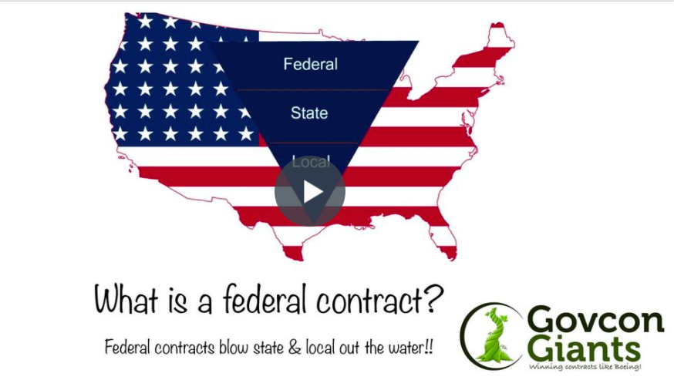

Pick a name! Any name!

Big hug,

Eric Coffie

